***These following Steps should be followed before or after installing the setup file !!!***

1. Copy the **Microsoft Access file (mad)** provided in the setup folder

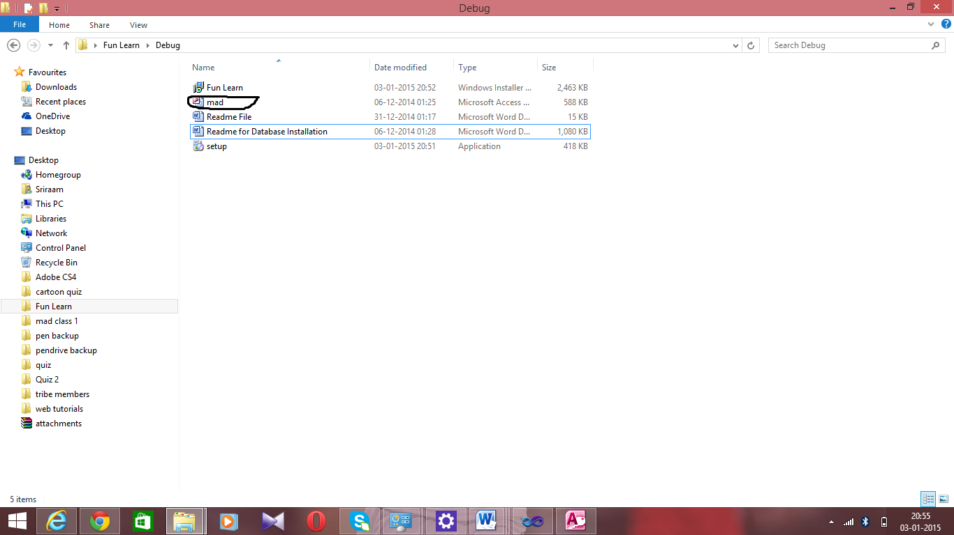

1. Copy the file to any location in ur local disk.
2. Then Go to Control Panel and select **Administrator Tools**.

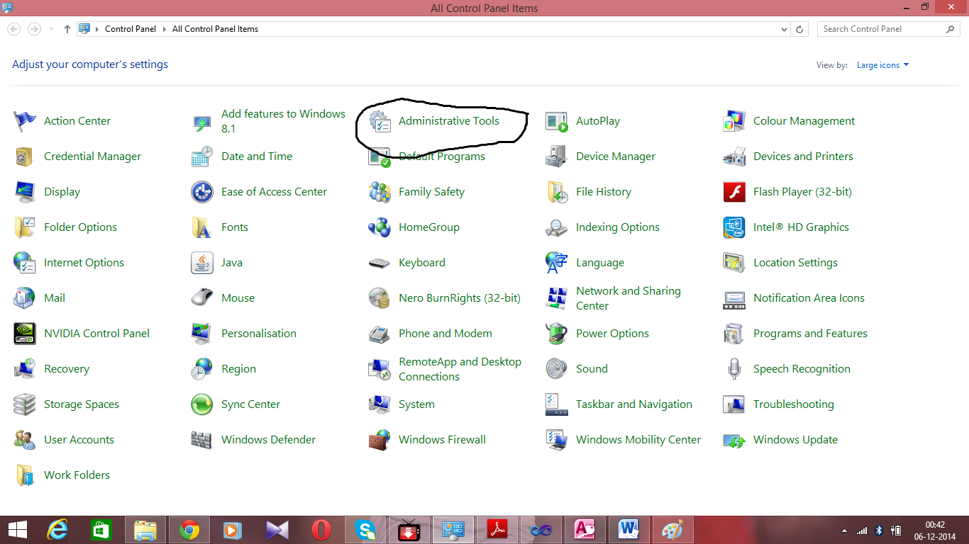

1. Open ODBC Data Sources option (in some cases ODBC Data Source (64 – bit) or ODBC Data Source (32 – bit) )

**NOTE :** If software shows error after added in ODBC Data Source (64 – bit) select **mad**1 in the list in the current dialogue box , Remove it and try adding in ODBC Data Source (32 – bit) or vice versa by following the same procedure .

1. Click Add
2. Look for Microsoft Access Driver (mdb,*accdb)

Or

Microsoft Access Driver(*mdb)

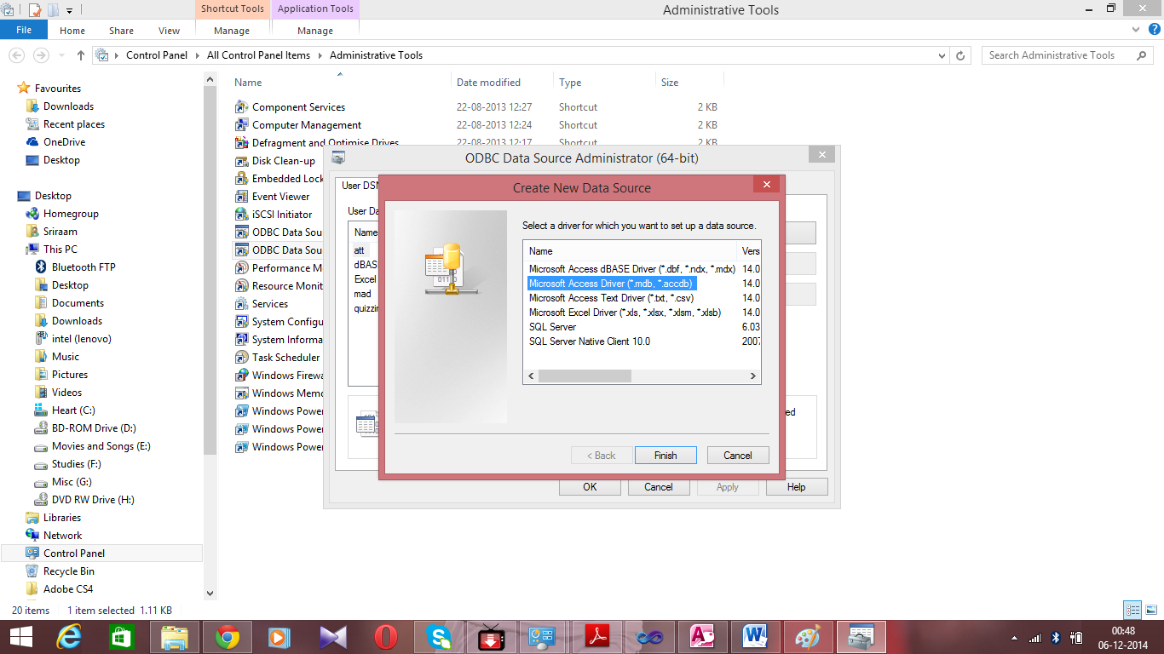

1. After selecting the option , click Finish
2. Then in the corresponding dialogue box , give Data Source Name as ‘ mad1’ .

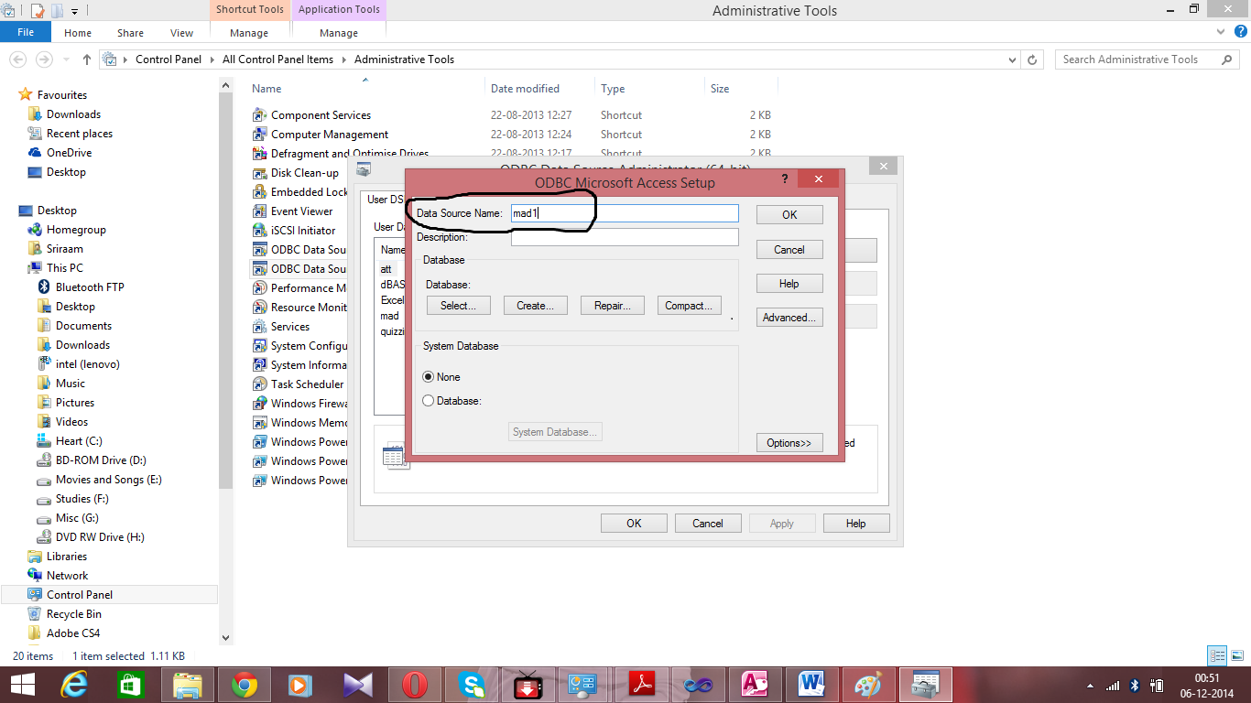

9 . Click Select button in the dialogue box , and move to the directory where u have saved your Microsoft Access File ( mad) and once ur in the corresponding directory , the database **mad.mdb** will get listed in the left pane.

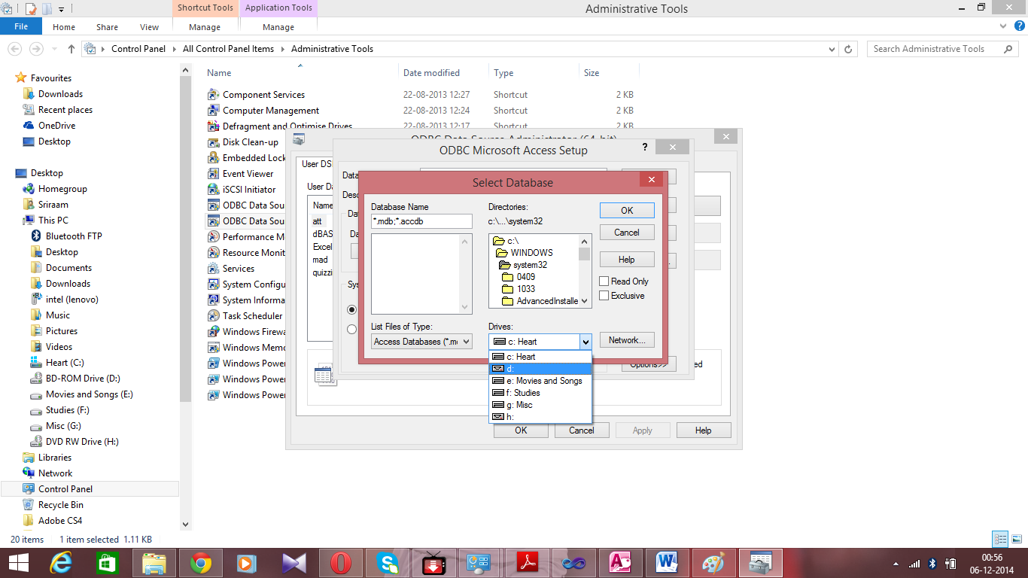

In this picture , I ve moved to the corresponding place , where I ve saved my directory , and so the Microsoft Access file(mad.mdb) gets listed in the left pane .

So the directory varies on ur own pc where you have saved the Microsoft Access file(mad.mdb)

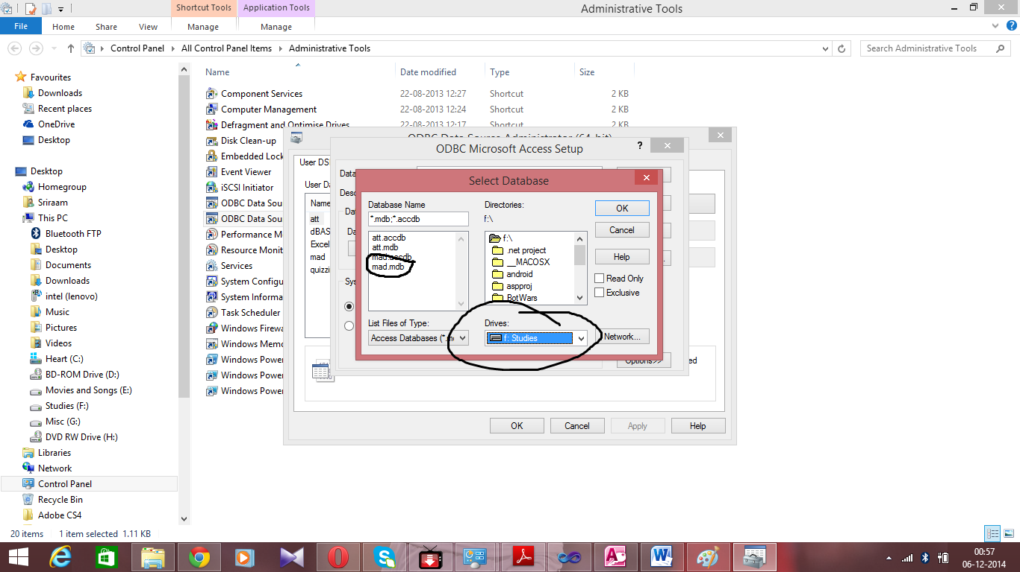

10.Click OK in the Select Database dialogue box

11. Click OK in the ODBC Microsoft Access Setup dialogue box .

**Now your software will work perfectly !!**